**Safeguarding and Child Protection Policy**

Home Grown Sports Development acknowledges the duty of care to safeguard and promote the welfare of children and is committed to ensuring safeguarding practice reflects statutory responsibilities, government guidance and complies with best practice and any partner organisations regulatory bodies requirements.

The policy recognises that the welfare and interests of children are paramount in all circumstances. It aims to ensure that regardless of age, ability or disability, gender reassignment, race, religion or belief, sex or sexual orientation, socio-economic background, all children

* have a positive and enjoyable experience of sport at Home Grown Sport Development in a safe and child centred environment
* are protected from abuse whilst participating in any activity or outside of the activity.

Home Grown Sports Development acknowledges that some children, including disabled children and young people or those from ethnic minority communities, can be particularly vulnerable to abuse and we accept the responsibility to take reasonable and appropriate steps to ensure their welfare.

As part of our safeguarding policy Home Grown Sports Development will

* promote and prioritise the safety and wellbeing of children and young people
* ensure everyone understands their roles and responsibilities in respect of safeguarding and is provided with appropriate learning opportunities to recognise, identify and respond to signs of abuse, neglect and other safeguarding concerns relating to children and young people
* ensure appropriate action is taken in the event of incidents/concerns of abuse and support provided to the individual/s who raise or disclose the concern
* ensure that confidential, detailed and accurate records of all safeguarding concerns are maintained and securely stored
* prevent the employment/deployment of unsuitable individuals
* ensure robust safeguarding arrangements and procedures are in operation.

The policy and procedures will be widely promoted and are mandatory for everyone involved in Home Grown Sports Development. Failure to comply with the policy and procedures will be addressed without delay and may ultimately result in dismissal/exclusion from the organisation.

**Monitoring**

The policy will be reviewed a year after development and then every three years, or in the following circumstances:

* changes in legislation and/or government guidance
* as required by the Local Safeguarding Children Board, UK Sport and/or Home Country Sports Councils and Partner organisations regulatory bodies
* as a result of any other significant change or event.

**Training and development**

Home Grown Sports employees and volunteers will attend training in recognising and understanding possible signs of child abuse and know what steps need to be taken to provide child protection. We will also offer opportunities to the wider sports and physical activity workforce across Cumbria to access a range of professional development opportunities. This will include the provision of subsidised access to: -

* Generic Safeguarding training opportunities via Cumbria Safeguarding Hub.
* Sport specific safeguarding training opportunities.
* Child Protection in Sport Unit training opportunities and events.
* NSPCC online training courses.
* Safeguarding training opportunities ran by organisations such as UK Coaching
* Encouraged to attain UK Coaching Duty of Care badge

**Contacts:**

Any concerns please contact

Garry Holmes

07964070713

[garry@homegrownsportsdevelopment.com](mailto:garry@homegrownsportsdevelopment.com)

Useful contact details:

Cumbria Safeguarding Hub

0333 2401727

www.cumbrialscb.com

Local Authority Designated Officer (LADO)

01768 812267

lado@cumbria.gov.uk

Child Protection in Sport Unit

0116 366 5590

www.thecpsu.org.uk

Child Line

0800 1111

**Reporting Procedures**

Outline safeguarding reporting procedure concerns

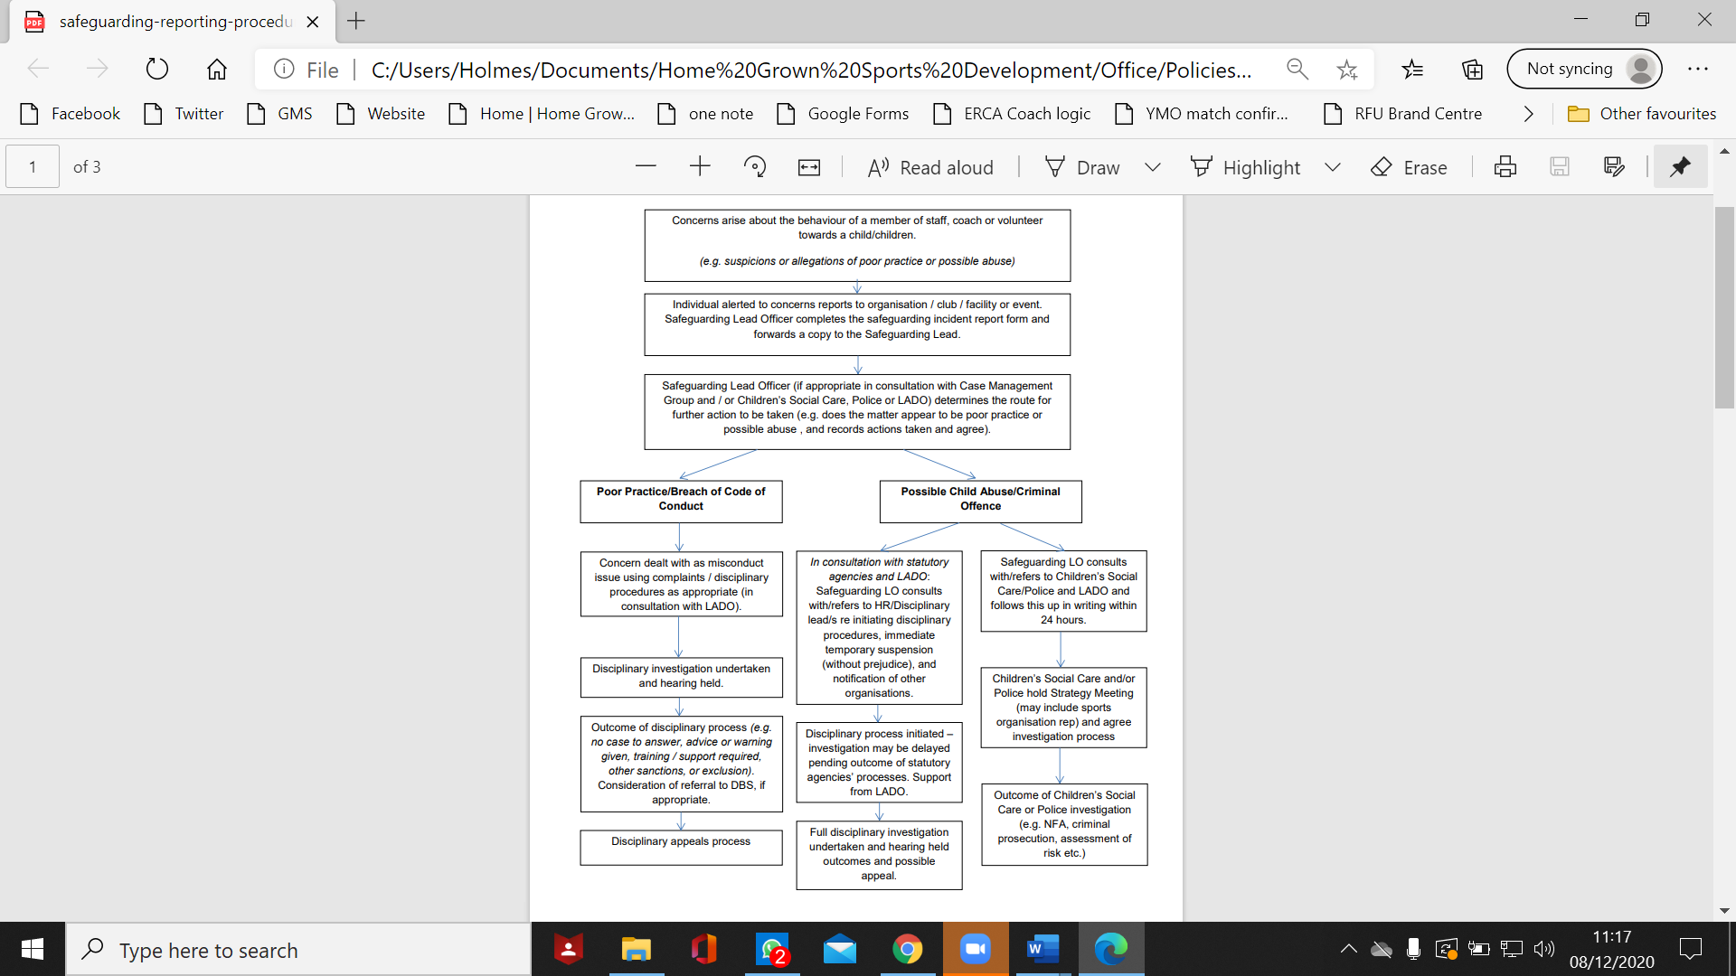**1. About the behaviour of the organisation’s staff member or volunteer**

(e.g. allegation about a coach or officer’s behaviour towards a child)

**2. About the behaviour of another organisation’s staff member or volunteer**

(e.g. allegations reported about an individual working for a partner organisation)

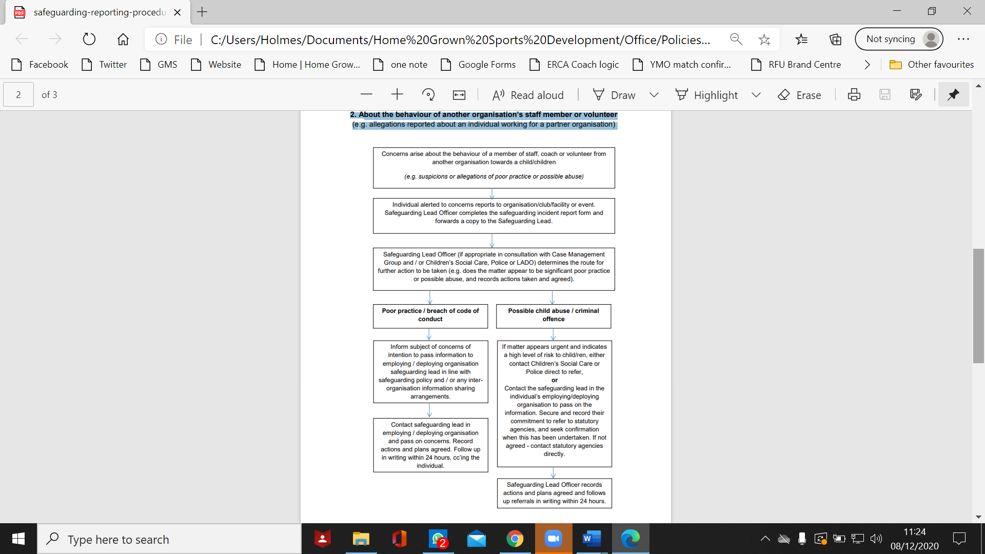

**3. About children and young people arising outside of sport**

(e.g. at home, school or in the community)

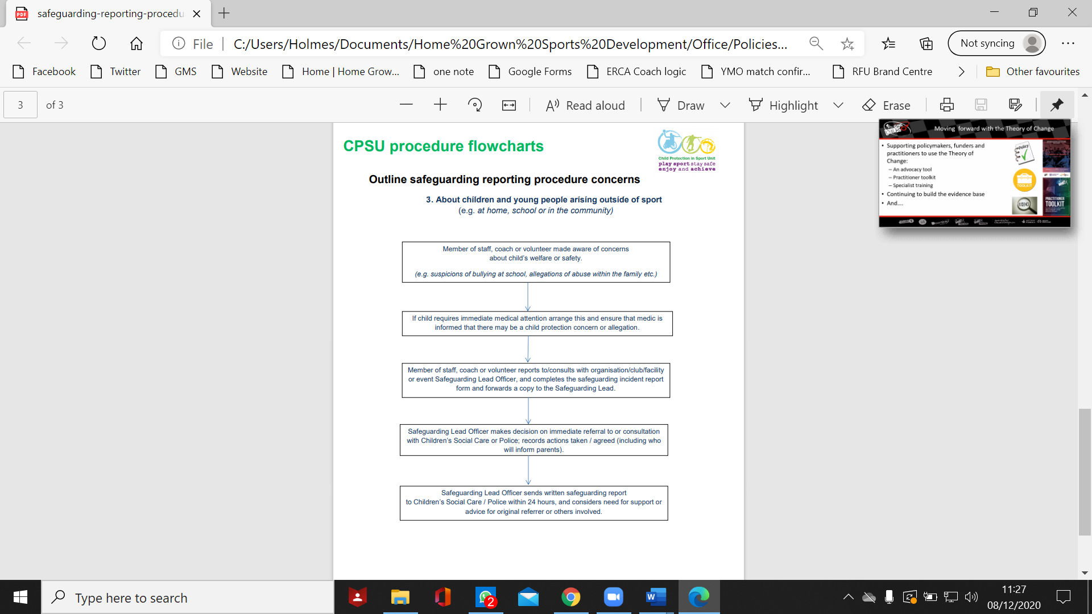

**Reporting Form**

|  |  |  |  |
| --- | --- | --- | --- |
| **Your information** | | | |
| Name |  | | |
| Address |  | | |
| Contact number(s) |  | | |
| Email |  | | |
| Name of organisation |  | Your role |  |

|  |  |  |  |  |  |
| --- | --- | --- | --- | --- | --- |
| **Personal information – child / young person** | | | | | |
| Name |  | | | Date of birth |  |
| Gender[1] | Male  🞎 | Female  🞎 | Non-binary  🞎 | Another description (please state)  🞎 | |
| Is there any information about the child that would be useful to consider? | | | | | |

|  |  |  |  |
| --- | --- | --- | --- |
| **Contact information – parent / carer** | | | |
| Name(s) |  | | |
| Address |  | | |
| Contact number(s) |  | | |
| Email |  | | |
| Have they been notified of this incident? | No  🞎 |  | Please explain why this decision has been taken |
| Yes  🞎 |  | Please give details of what was said / actions agreed |

|  |  |  |  |  |  |  |  |
| --- | --- | --- | --- | --- | --- | --- | --- |
| **Incident details\*** | | | | | | | |
| Date and time of incident | | |  | | | | |
| Please tick one: | 🞎 | I am reporting my own concerns. | | 🞎 | I am responding to concerns raised by someone else – please fill in their details: | | |
| Name of person raising concern | | |  | | | Role within the sport or relationship to the child |  |
| Contact number(s) | | |  | | | | |
| Email | | |  | | | | |
| Details of the incident or concerns (include other relevant information, such as description of any injuries and whether you are recording this incident as fact, opinion or hearsay) | | | | | | | |

* Attach a separate sheet if more space is required (e.g. multiple witnesses)

|  |  |  |  |  |  |  |  |
| --- | --- | --- | --- | --- | --- | --- | --- |
| **Incident details (continued)** | | | | | | | |
| Child’s account of the incident | | | | | | | |
| Please provide any witness accounts of the incident | | | | | | | |
| Name of witness (and date of birth, if a child) |  | | Role within the sport or relationship to the child | | | |  |
| Address |  | | | | | | |
| Contact number(s) |  | | | | | | |
| Email |  | | | | | | |
| Details of any person involved in this incident or alleged to have caused the incident / injury | | | | | | | |
| Name (and date of birth, if a child) |  | | Role within the sport or relationship to the child | | | |  |
| Address |  | | | | | | |
| Contact number(s) |  | | | | | | |
| Email |  | | | | | | |
| Please provide details of action taken to date | | | | | | | |
| Has the incident been reported to any external agencies? | | | | 🞎 | No | 🞎 | Yes – please provide further details: |
| Name of organisation / agency | |  | | | | | |
| Contact person | |  | | | | | |
| Contact number(s) | |  | | | | | |
| Email | |  | | | | | |
| Agreed action or advice given | | | | | | | |

|  |  |
| --- | --- |
| **Declaration** | |
| Your signature | 🗶 |
| Print name |  |
| Today’s date |  |

|  |  |
| --- | --- |
| Contact your organisation’s Designated Safeguarding Officer in line with **[insert name of your organisation]**’s reporting procedures | |
| Safeguarding Officer’s name |  |
| Date reported |  |

1.